PRINCIPLES OF DATA SCIENCE

**ASSIGNMENT-1**

MANOJ KUMAR SUGGALA

**(16357169)**

**Task-2:**

**Data Analysis of Task-2**

Some of the visualizations we performed on the data are:

1 Distribution of genders:

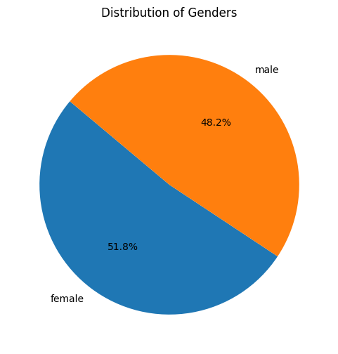

2 Distribution of parental level of education

3 Test completed based on lunch type:

4 Distribution of test scores by gender:

